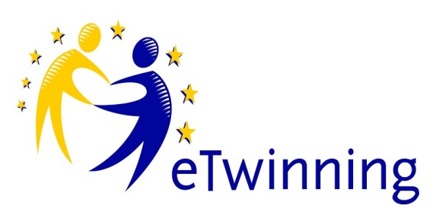
THE EDGAR PROJECT- DISCOVERING SCHOOLS AND ROUTES IN EUROPE WITH EDGAR
The project "Discovering schools and routes in Europe with Edgar" aims to send Edgar, the mascot of the European Mobility Week, on a real and digital tour through Europe.
Thus enabling to enter (inter) cultural and interactive exchanges with elementary schools from different countries. Through the cooperation of the different school classes via the twinspace platform, pupils, who are aged from 5 to 12 years, have the opportunity to experience Edgar in various European locations and to learn more about the country itself and the (school) life of the local people. Participating school classes have the task of gathering information material on topics such as language, country-specific traditions and festivals, food, music, games and the school system and make it publicly available online. In addition, it is planned to set up a chat room, which will allow regular communication directly with partner classes across national borders. Another special focus of the project, in addition to the general exchange of information, is the joint discussion on sustainable mobility. Edgar is not only a medium for diversity, but also an identifier of a Europe on the move and a Europe, whose environment needs to be protected. "Discover ways together with Edgar" aims to travel around environmentally friendly with Edgar, by bike, bus, train, on foot and to make children aware of this topic. The mascot Edgar is to accompany school classes on their paths inside and outside the school grounds, on excursions, rides, hikes, tours, school trips, etc.
As a common result, an Edgar photo collection will be created, which captures Edgar 's sustainable mobility and can be used as a thematic impulse for teaching.
OBIETTIVI
- Expertise:
The pupils...
a) …get to know different school locations in Europe
b) …experience new knowledge about school life here and elsewhere
c) …get to know country-specific feature
d) …get to know different opportunities of sustainable mobility
(2) Social skills and self-competences:
The pupils…
a) …learn to communicate with kids from everywhere in Europa und try to speak in another language
b) …get to know culture diversity
c) …experience a sense of being WE through the realization of a common idea as well as through the common identification figure Edgar
d) …learn to be cosmopolitan and tolerant
e) …experience joy in getting to know other people and their lifestyle
(3) Methodological skills:
The pupils…
a) …use digital media to take pictures of their business with Edgar
b) …use media such as tablets and PCs and the internet to obtain and collect information about the respective European countries and schools
c) …enter into an interactive exchange with other school classes in Europe via a chat platform
d) …learn to send international mail

PROCEDURA DI LAVORO

Headquarters of the project
Members: Muriel from Belgium, Lara from Italy and Tobias from Germany
Tasks:
- Regular meetings two times per month
- Organize online meetings with all participants (one time during three month)
- Developing basic twinspace material for using in classes till September
- Contact persons for questions
Participants of the project:
Schools from Belgium, Spain, France, Greece, Italy, Germany, Finland, Portugal
Teachers tasks:
- Help to receive and send Edgar
- Pay attention to the proper handling of Edgar
- Complete the online cover letter with the kids
- Allow sharing / usage via twinspace
- Keep time window of maximum 10 days
Pupils tasks:
• Receive and send Edgar package with the help of the teacher
• Complete the online profile with teacher
• Take pictures and / or videos of how to learn, play and travel with Edgar and upload them
* At least 1 travel photo for sustainable mobility
• Chat once a month with partner school
Time schedule:
(A) Already done:
*The core team of headquarters has exchanged online, exchanged by phone and partly met
•Collected project ideas to implement the Edgar project
• First designs for working materials for twinspace have been created
• the project description has been created
• There is a itinerary for 2 Edgar dolls
• 2 Edgar dolls were sent away (1. Edgar was sent to Belgium from Erfurt (Germany), 2. Edgar from Erfurt-Berlin-Bologna, was handed over directly)
• first pictures were made in Erfurt, Belgium and Italy
• Official project start is in September
(B) Next steps to do:
- Project to be opened (Tobias)
- The appropriate materials for the kids and teachers are to be uploaded to twinspace
Chat platform should arise
- First photos with Edgar are to be uploaded
- official start of the project and start of the twinspace website will be in September

RISULTATI ATTESI

1. Enjoying the sharing of experiences, adventures and actions of school classes and Edgar
2. A public twinspace website with diverse country-specific information on all participating schools / countries that can be accessed by students and teachers has been created
3. Exchange online meetings (twinspace chat) of school classes took place
4. A photo collection on the subject "Sustainably on the road with Edgar" has been created
5. Edgar has been in each participating country for at least 1 week; after one year Edgar is back in Germany
6. A possible further development of the project into an Erasmus + project with the aim of a Europe-wide teacher exchange

